* **Name of the Activity:** A seminar on "Journey through Wormhole"
* **Type of the Activity:** Seminar for UG students
* **Organizing Department:** Department of Physics, Chakdaha College
* **Date and time of the Activity:** 23.12.2021 from 11:00 a.m – 14:00 pm
* **Number of participants**: 57
* **Speakers:** Dr. Saibal Roy, Associate Professor, Department of Basic Sciences Engg and Humanities, Government College of Engineering & Ceramic Technology
* **Outcome:**

In the seminar **"Journey through Wormhole"** the students have got the opportunity to learn about the existence of an anti-matter of black-hole called worm-hole through which the energy flux is emitted. The students and the faculty members from other departments of this college also participated in this seminar and they got a chance to meet and learn from an eminent speaker and academician like Dr. Saibal Roy. The inquisitive minds of the students also get enthusiasm to learn about different astronomical phenomena.

* **Photographs of the Programme:**

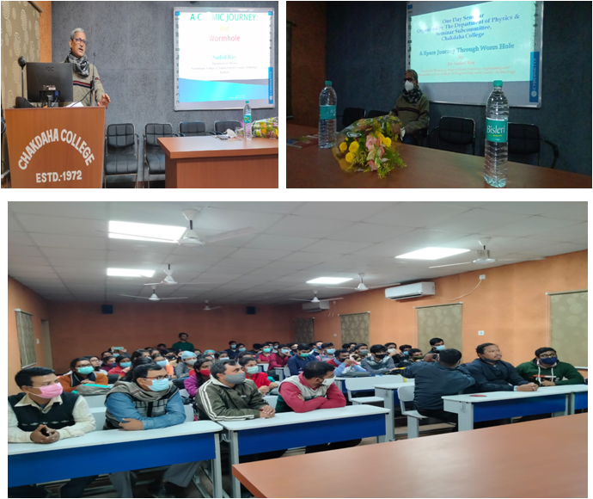

* **Attendance:**

